**Girl Guides of Canada**

**Thompson Nicola Area Awards Committee**

**Quick Reference of Youth Program Awards**

**Sparks**

**Fun and Friendship Pin**

This is given to a Spark at an advancement ceremony to indicate that they have completed their time in Sparks. Printable versions of the Spark Advancement Certificate are available at: <https://experience.girlguides.ca/node/1312011>

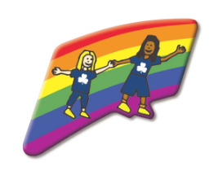

**Embers**

**Fun & Adventure Key Pin**

Given at advancement ceremony to indicate that the Ember has completed their time in Embers. Printable versions of the Embers Advancement Certificate are available at: <https://experience.girlguides.ca/node/1312011>



**Guides**

**Guide Challenge Pin**

Given at advancement ceremony to indicate that the youth has completed their time in Guides. Printable versions of the Guide Advancement Certificate are available at: <https://experience.girlguides.ca/node/1312011>

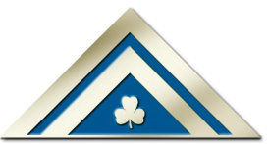

**Lady Baden-Powell Challenge**

Presented by the Unit Guider when the Guide has completed the challenge requirement. This is the highest award in the Guide Program. The Lady Baden-Powell Challenge certificates are usually presented by Thompson Nicola Area at an Area/District/Unit Recognition Ceremony.

To track this award completion in iMIS, the Thompson Nicola Area Awards Liaison will fill out the Branch Program Awards form.

 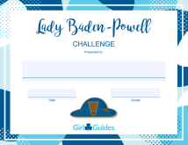

**Pathfinders**

**Building Belonging Certificate**

Canadian communities are made up of diverse cultures and unique individuals. Earning the Building Belonging Certificate (formerly known as the Citizenship Certificate) means that the youth understand why it is important for Canada to be a place where everyone can feel like they belong. It also means that the youth took the time to explore the greatness of Canadian communities and people in them. To earn this certificate, the youth must complete either 2-4 activities from each theme or 6-10 activities in total. This can be found in the Girls First Program. Once the youth has completed the requirements, printable versions of the certificate are available at: <https://experience.girlguides.ca/node/1312011>

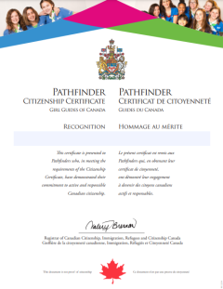

**Community Service Award**

This is presented to a Pathfinder by their Unit Guider upon completions of community serve projects. This is one requirement for earning the Canada Cord.

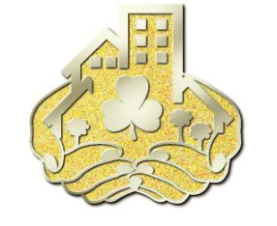

**Canada Cord**

Refer to program for requirements. The Canada Cord is the highest award that a Pathfinder can earn. The Canada Cord certificates are usually presented by Thompson Nicola Area at an Area/District/Unit Recognition Ceremony.

To track this award completion in iMIS, the Thompson Nicola Area Awards Liaison will fill out the Branch Program Awards form.

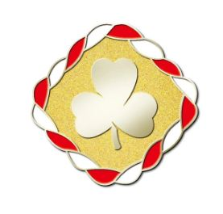 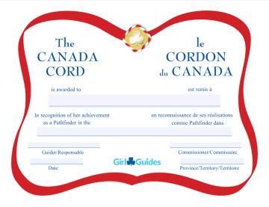

**Rangers**

**Ranger Certificate of Appreciation**

This certificate may be given annually to recognize service as a Ranger. Printable versions of the certificate are available at: <https://experience.girlguides.ca/node/1312011>

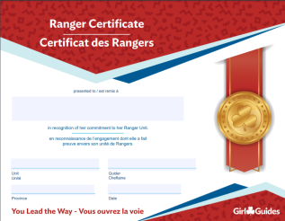

**Ranger Service Project Pin & Certificate**

Complete one major service project of at least 20 hours including planning. Pin and certificate awarded by the Unit Guider. Printable versions of the certificate are available at: <https://experience.girlguides.ca/node/1312011>

 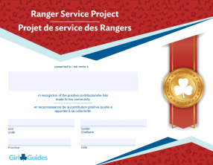

**Cookie Challenge Pin & Certificate**

Actively participate in four cookie campaigns as a Ranger. Pin and certificate awarded by the Unit Guider. Printable versions of the certificate are available at: <https://experience.girlguides.ca/node/1312011>

 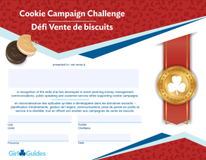

**Trailblazer Leadership Bronze Award**

Refer to program for requirements. Pin and certificate awarded by the Unit Guider. Printable versions of the certificate are available at: <https://experience.girlguides.ca/node/1312011>

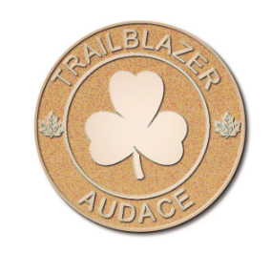 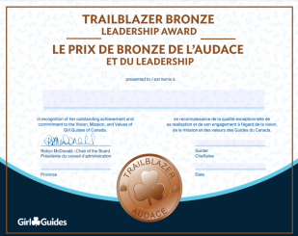

**Trailblazer Leadership Silver Award**

Refer to program for requirements. Pin and certificate awarded by the Unit Guider. Printable versions of the certificate are available at: <https://experience.girlguides.ca/node/1312011>

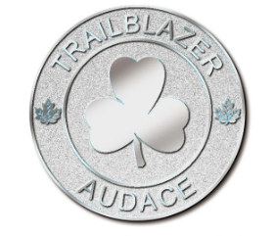 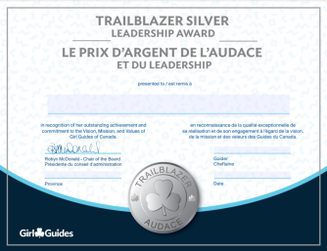

**Trailblazer Leadership Gold Award**

Awarded on completion of the Bronze and Silver Awards, the Ranger Service Project and the Cookie Campaign Challenge. This award (pin and ribbon) is presented by the Unit Guider in the youth’s third year.

The certificate is usually presented by Thompson Nicola Area at an Area/District/Unit Recognition Ceremony.

Congratulations Letter request form is requested from National by the Thompson Nicola Area Awards Committee and letters will be presented at an Area/District/Unit award ceremony.

To track this award completion in iMIS, the Thompson Nicola Area Awards Liaison will fill out the Branch Program Awards form.

Upon receiving their certificate, they may present it to their school counsellor to obtain school credits.

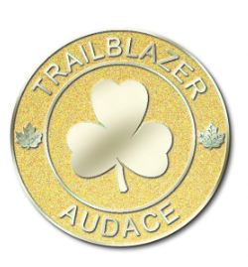 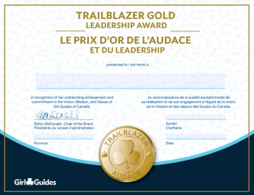

**Commonwealth Award**

Youths registered in Rangers are eligible to earn this award. It can be found here <https://www.girlguiding.org.uk/what-we-do/our-badges-and-activities/badge-finder/commonwealth-award/>

Pin and certificate awarded by the Unit Guider. Printable versions of the certificate are available on the Girl First Program under Navigation/Certificates and Awards/Rangers.

This certificate can be presented by Thompson Nicola Area at an Area/District/Unit Recognition Ceremony. You should check the process with your Area Awards Liaison for further clarification of your Area’s process.

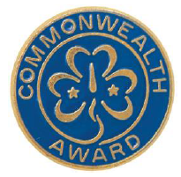 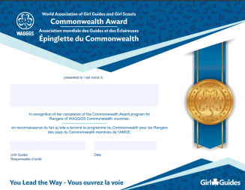

**BC Girl Guides – Youth Commitment Pin**

The Youth Commitment Award is presented to third-year Rangers who have been a member in all branches from Sparks through to Rangers in recognition and celebration of their long-term commitment to Guiding. To qualify members must have:

* one or two years of Sparks
* two years of Embers
* three years of Guides
* three years of Pathfinders
* three years of Rangers

The list of Rangers eligible for the Youth Commitment Award will be generated from the iMIS records. Certificates are sent automatically in the Spring to the Ranger Contact Guider for presentation to all eligible members.   
No application is necessary.

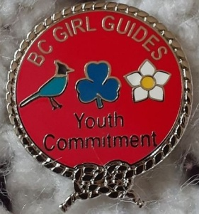

**Guides, Pathfinders and Rangers**

**Junior Leader Certificate of Appreciation**

A Junior Leader is committed to working with a unit in a branch of Guiding where the youth are at least two years younger than they are (i.e. Guides can support a Sparks unit). A youth can choose to be a Junior Leader while they works on the Guide/Pathfinder/Ranger program or they can focus on the Junior Leader role. They can rejoin the Guide/Pathfinder/Ranger program anytime.

Each unit will have to register their Junior Leaders each year.

Please contact [info@girlguides.ca](mailto:info@girlguides.ca) to have the youth registered in your unit as a Junior Leader.

Printable versions of the certificate are available at: <https://experience.girlguides.ca/node/1312011>

You can go into any branch and find this certificate.

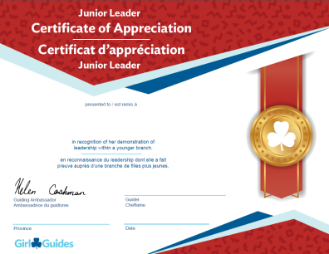

If you have any questions, please contact:

Donna Samson

Thompson Nicola Area Awards Liaison

[tnaaward@gmail.com](mailto:tnaaward@gmail.com)

250-320-7582