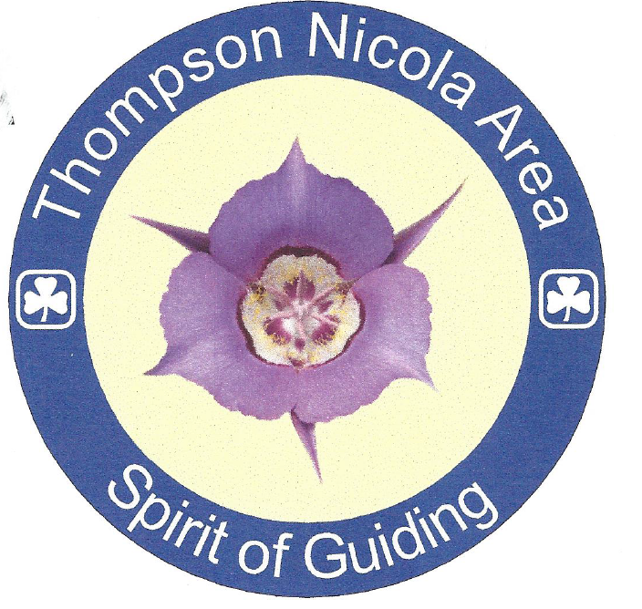



In 2015 the Thompson Nicola Area started its very own award for its dedicated Guiders in our Area.
The Mariposa Lily was chosen. It is a wildflower found all over our Thompson Nicola Area. The Mariposa Lily is a quiet, unpretentious flower which, nevertheless, is resilient especially after a disaster - like the wild fires that sweep our region ever so often. Usually after a disaster like that, because of its deep roots, it comes back stronger than ever. When blooming in mass, it is an impressive sight – much like our Guiders in blue or purple. The Mariposa Lily in this region is almost a shade of lavender or purple and when you mix colours purple is achieved by mixing blue and pink. Isn’t that how our colours work in Guiding?...a young pink, gradually moving to blue and in the end the mixture gives you a mature lavender or purple. It was felt, many of the characteristics of the Mariposa Lily are found in our dedicated and hard working Guiders; so it was decided to make it our symbol of the “Spirit of Guiding Award”.

ELIGIBILITY:
To be eligible for this award:
- The Guider must be a Guider in the Thompson Nicola Area for a minimum of 3 years
- The Guider must be involved in one or more aspects of Guiding over the years.
- The Guider has made significant contributions to Girl Guides of Canada in the Thompson Nicola Area and/or their community, which have created a positive impact on Guiding within the Thompson Nicola Area.
- This award can be for their service given as a Unit Guider, Administrator, Trainer, Mentor, Adviser or other Guiding position.
- This Guider has gone out of their way to make Guiding a wonderful experience for all members.

REQUIREMENTS:
- Nominations can come from: Area Commissioner(s), Guiders or youth members.
- Two letters of support must be submitted to the Area Awards Liaison.

APPROVAL PROCESS:
- Approval from the Area Commissioner(s) in consultation with the Area Awards Committee.

DEADLINE FOR RECEIPT OF APPLICATION AND SUPPORTING DOCUMENTS
5 P.M. March 31th

LATE APPLICATIONS WILL NOT BE CONSIDERED

Complete the application form and two supporting documents and email to:

Thompson Nicola Area – Spirit of Guiding Award
Donna Samson – Thompson Nicola Area Award Liaison
tnaaward@gmail.com

Date:
Nominee’s Name
Nominee’s IMIS #
Nominator’s Name
Nominator’s IMIS #
Nominator’s Email
Area Commissioner Signature
IMIS #

Attach two recommendation letters.

