Girl Guides of Canada
Thompson Nicola Area Awards Committee
Quick Reference of Youth Program Awards

SPARKS

Fun and Friendship Pin
This is given to a Spark at an advancement ceremony to indicate that they have completed their time in Sparks. There is a printable version of the Spark Advancement Certificate available on the National website in Member Zone under Guider Resources/Programs/Are you a new Spark Guider/For Spark Guiders/Spark certificates.

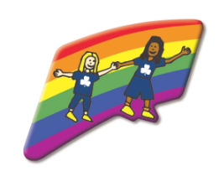

EMBERS

Fun & Adventure Key Pin
Given at advancement ceremony to indicate that the Ember has completed their time in Embers. There is a printable version of the Embers Advancement Certificate available on the National website in Member Zone under Guider Resources/Programs/Are you a new Ember Guider/For Ember Guiders/Ember certificates.

GUIDES

Guide Challenge Pin
Given at advancement ceremony to indicate that the youth has completed their time in Guides. There is a printable version of the Guide Advancement Certificate on the National website in Member Zone under Guider Resources/Programs/Are you a new Guide Guider/For Guide Guiders/Guide certificates.

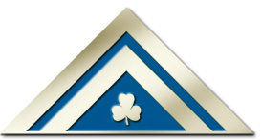

Lady Baden-Powell Challenge
Presented by the Unit Guider when the Guide has completed the challenge requirement. This is the highest award in the Guide Program. Certificates are processed through the Area Awards Committee and are usually presented at an Area Recognition Ceremony.

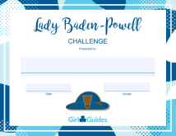

PATHFINDERS

Citizenship Certificate
A youth must complete two activities from each of the sections in the Be a Model Citizen module (eight activities total) plus a service project. Please find the most updated version of the Be a Model Citizen module in Member Zone on the National website. Once the youth has completed the requirements, a printable version of the certificate is available on the National website in Member Zone under Guider Resources/Programs/Are you a new Pathfinder Guider/For Pathfinder Guiders/Pathfinder certificates.

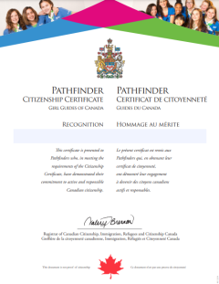

Community Service Award
This is presented to a Pathfinder by their Unit Guider upon completions of community serve projects. This is one requirement for earning the Canada Cord.

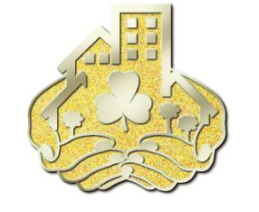

Canada Cord
Refer to program for requirements. The Canada Cord is the highest award that a Pathfinder can earn. The Canada Cord certificates are processed through the Area Awards Committee and are usually presented at an Area Recognition Ceremony.

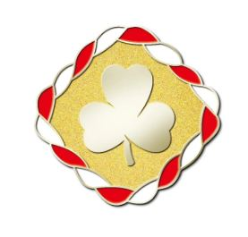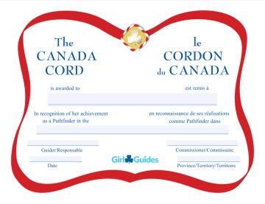

RANGERS

Ranger Certificate of Appreciation
This certificate may be given annually to recognize service as a Ranger. Printable versions of the certificate are available on the National website in Member Zone under Guider Resources/Programs/Resources for Rangers.

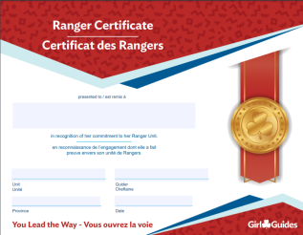

Ranger Service Project Pin & Certificate
Complete one major service project of at least 20 hours including planning. Pin and certificate awarded by the Unit Guider. Printable versions of the certificate are available on the National website in Member Zone under Guider Resources/Programs/Are you a new Ranger Guider/For Ranger Guiders page/Ranger certificates.

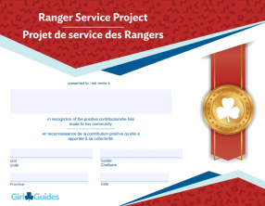

Cookie Challenge Pin & Certificate
Actively participate in four cookie campaigns as a Ranger. Pin and certificate awarded by the Unit Guider. Printable versions of the certificate are available on the National website in Member Zone under Guider Resources/Programs/Are you a new Ranger Guider/For Ranger Guiders page/Ranger certificates.

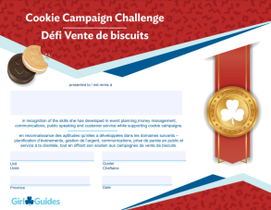

Trailblazer Leadership Bronze Award
Refer to program for requirements. Pin and certificate awarded by the Unit Guider. Printable versions of the certificate are available on the National website in Member Zone under Guider Resources/Programs/Are you a new Ranger Guider/For Ranger Guiders page/Ranger certificates.

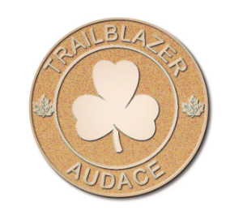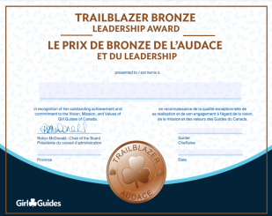

Trailblazer Leadership Silver Award
Refer to program for requirements. Pin and certificate awarded by the Unit Guider. Printable versions of the certificate are available on the National website in Member Zone under Guider Resources/Programs/Are you a new Ranger Guider/For Ranger Guiders page/Ranger certificates.

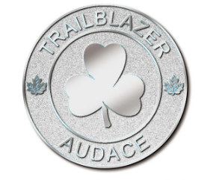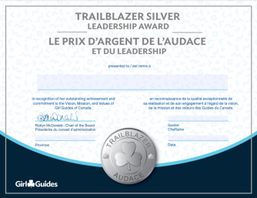

Trailblazer Leadership Gold Award
Awarded on completion of the Bronze and Silver Awards, the Ranger Service Project and the Cookie Campaign Challenge. This award (pin and ribbon) is presented by the Unit Guider in the youth’s third year or when they complete all requirements. This award is the highest award that a Ranger can earn.
The certificate is usually presented at an Area Recognition Ceremony and you should check the process with your Area Awards for further clarification of your area’s process.
Upon receiving their certificate they may present it to their school counsellor to obtain school credits.

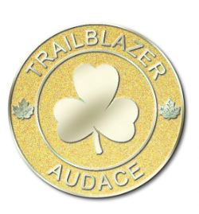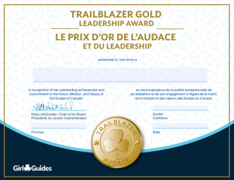

Commonwealth Award
Youths registered in Rangers are eligible to earn this award. It can be found here https://www.girlguiding.org.uk/what-we-do/our-badges-and-activities/badge-finder/commonwealth-award/
Pin and certificate awarded by the Unit Guider. Printable versions of the certificate are available on the National website in Member Zone under Guider Resources/Programs/Are you a new Ranger Guider/For Ranger Guiders page/Ranger certificates.
The certificate can be presented at an Area Recognition Ceremony and you should check the process with your Area Awards for further clarification of your area’s process.

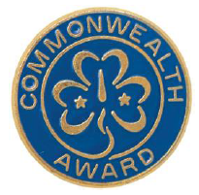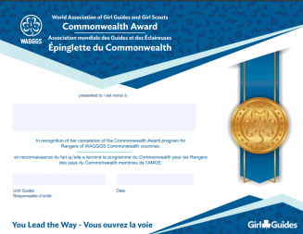

BC Girl Guides – Youth Commitment Pin
The Youth Commitment Award is presented to third-year Rangers who have been a member in all branches from Sparks through to Rangers in recognition and celebration of their long-term commitment to Guiding. To qualify members must have:
- one or two years of Sparks
- two years of Embers
- three years of Guides
- three years of Pathfinders
- three years of Rangers
The list of Rangers eligible for the Youth Commitment Award will be generated from the iMIS records. Certificates are sent automatically in the Spring to the Ranger Contact Guider for presentation to all eligible members.
No application is necessary.

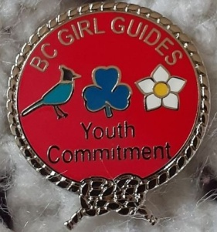

Guides, Pathfinders and Rangers

Junior Leader Certificate of Appreciation
A Junior Leader is committed to working with a unit in a branch of Guiding where the youth are at least two years younger than they are (i.e., Guides can support a Sparks unit). A youth can choose to be a Junior Leader while they work on the Guide/Pathfinder/Ranger program or they can focus on the Junior Leader role. They can rejoin the Guide/Pathfinder/Ranger program anytime.
Each unit will have to register their Junior Leaders each year.
Please contact info@girlguides.ca to have the youth registered in your unit as a Junior Leader.
Printable versions of the certificate are available on the National website in Member Zone under Guider Resources/Programs/Are you a new Ranger Guider/For Ranger Guiders page/Junior Leaders/Junior Leader Certificate.

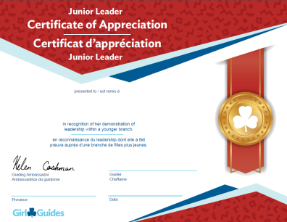

If you have any questions, please contact:

Donna Samson
Thompson Nicola Area Awards Liaison
tnaaward@gmail.com
250-320-7582

