

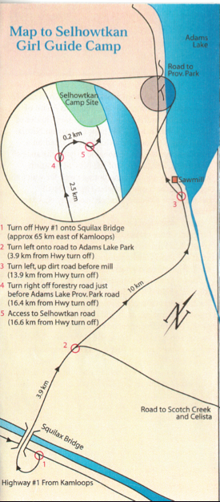

camp selhowtkan

HISTORY

The campsite is named after an Indian Chief named Selhowtkan who was also referred

to as Adam of Adams Lake. In the early 1970’s the Girl Guides of Canada - Walhachin Area (now Thompson Nicola Area) began to look for a campsite

located on a lakeshore & within reasonable driving distance of Kamloops. The location of the present campsite looked pretty good having both a creek for water & a good beach. It was part of a Timber Berth belonging to Holding Timber Company of Adams Lake.

Many local organizations contributed to the building of the campsite: Moose Lodge #1552 constructed the Brownie Hut. The Sorrento Lions club built the Picnic Shelter at the beach. Volunteers built the Lifeguard cabin, outhouses & the QM building. A “Buy a Brick” campaign was held to raise money for the QM and names of donors were painted on the building. One group from Sorrento really got into the campaign, each & every member of the group had their names individually painted on a brick! The welding class at the University College of the Cariboo built the fireplace grills complete with Trefoil motif!

The first camps were held in the summer of 1974. Since the beginning in 1970, countless volunteers have spent endless hours helping with the construction, building & upkeep of Camp Selhowtkan.

